

POINTNO. 58,59,60,61,62,63,64 In Specification

Release Note

www.projectobjects.com

support@projectobjects.com

Table of Contents

PRJ Direct Assignment Form, “Procurement Plan Item” field logic 3

Overview: 3

PRJ Direct Assignment form, automatic filling of Procurement plan details fields 3

Overview: 3

Prj direct assignment Form, Automatic Filling of Project Details fields 4

Prj direct assignment Form, “Approver” field logic 5

Overview: 5

Overview: 6

Form Details: 6

PRJ Direct Assignment, “Outcome” field logic 7

PRJ Direct Assignment, “DA Authorization Date” field logic 8

Overview: 8

Form Details: 8

Functionality details: 8

## 

# PRJ Direct Assignment Form, “Procurement Plan Item” field logic

## Overview:

In this release, we have developed the procurement plan item dropdown is showing only Procurement Plans that have the "Procurement Procedure" field equal to "Direct Assignment" related to this project.

FUNCTIONALITY DETAILS:

We have made dropdown procurement paln item ,which have to show Procurement Plans that have the "Procurement Procedure" field equal to "Direct Assignment" related to this project.

* Procurement plan item will showing only that procurement plan which has procurement procrdure fields equals to direct assignment.

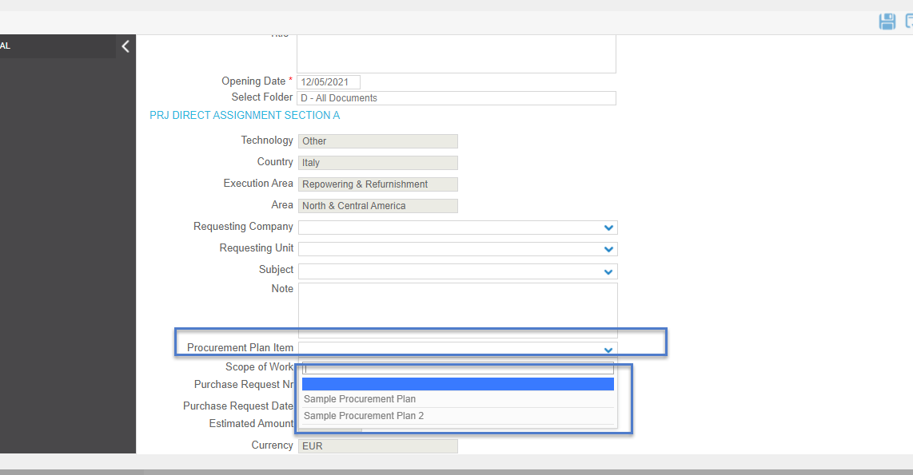

# PRJ Direct Assignment form, automatic filling of Procurement plan details fields

## Overview:

In this release we have created the logic, Automatically Fill the project information details in the PRJ Direct Assignment form from Procurement Plan Form.

FUNCTIONALITY DETAILS:

* User select the procurement plan in procurement plan item dropdown.
* Following field will be retrieve

**SoW**

**Purchase Request Nr**

**Purchase Request Date**

**Estimated Amount**

**Currency**

**Equivalent Estimated Amount (€)**

**Requested Supplier**

* All fields which will be retrieve would be non editable

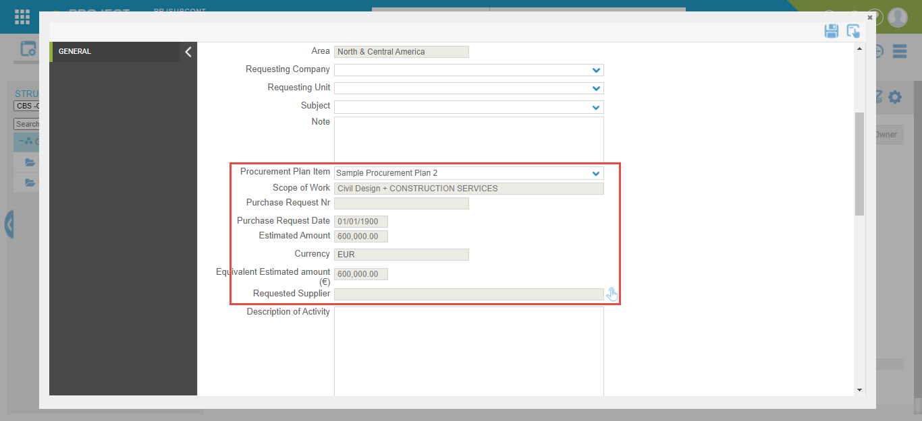

# Prj direct assignment Form, Automatic Filling of Project Details fields

Overview:

In this release, we have implemented an automatic filling of project field details in the **PRJ DIRECT ASSIGNMENT** form.

Form Details:

* We have removed the binding icon from the **Technology, Country** fields and remove the dropdown, and made all data retrievable fields non-editable.
* We have developed a new function to retrieve project field details in the **PRJ DIRECT ASSIGNMENT** form.

Functionality Details:

* When a user creates a new **PRJ DIRECT ASSIGNMENT object** then data in **Country, Technology, Execution Area, Area,**  fields are retrieved from the project detail fields.
* These fields will be always non-editable manually.
* If the user changes the project details then the change will automatically reflect in new and existing forms.

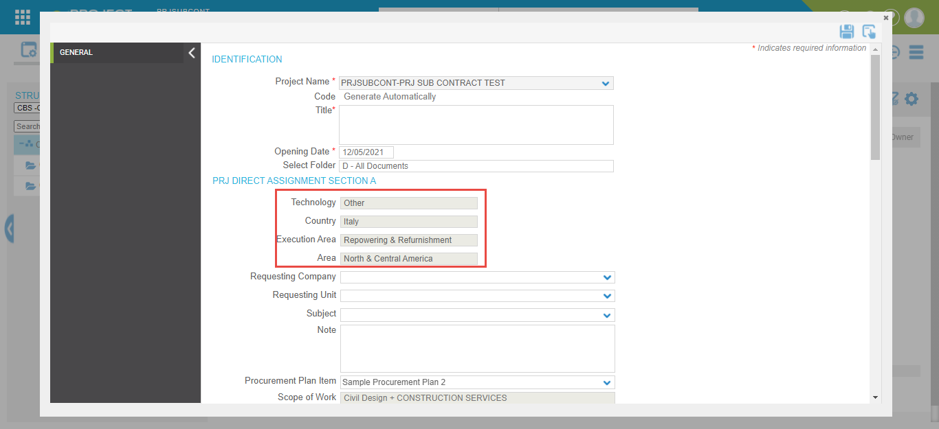

# Prj direct assignment Form, “Approver” field logic

## Overview:

In this release, we have developed the dropdown field and **PRJ-DA APROOVER** group, which have some user.

FUNCTIONALITY DETAILS:

We have made dropdown **APROOVER** which have shows only those users who are belongs to **PRJ-DA APROOVER** group.

* User group will associated with second step
* Only **PRJ-DA APROOVER** group users will shows in dropdown

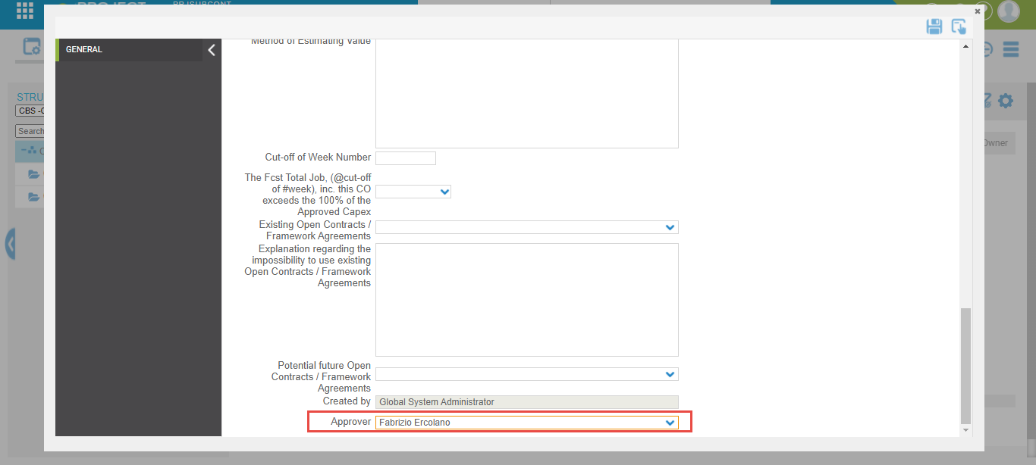

# PRJ Direct Assignment Form, “Created by” field logic

## Overview:

In this release we have implemented created by field logic.

## Form Details:

* Created by field is non editable

Functionality details:

* Field show the name of user who created the object , when any object will created by user then user name will show in field

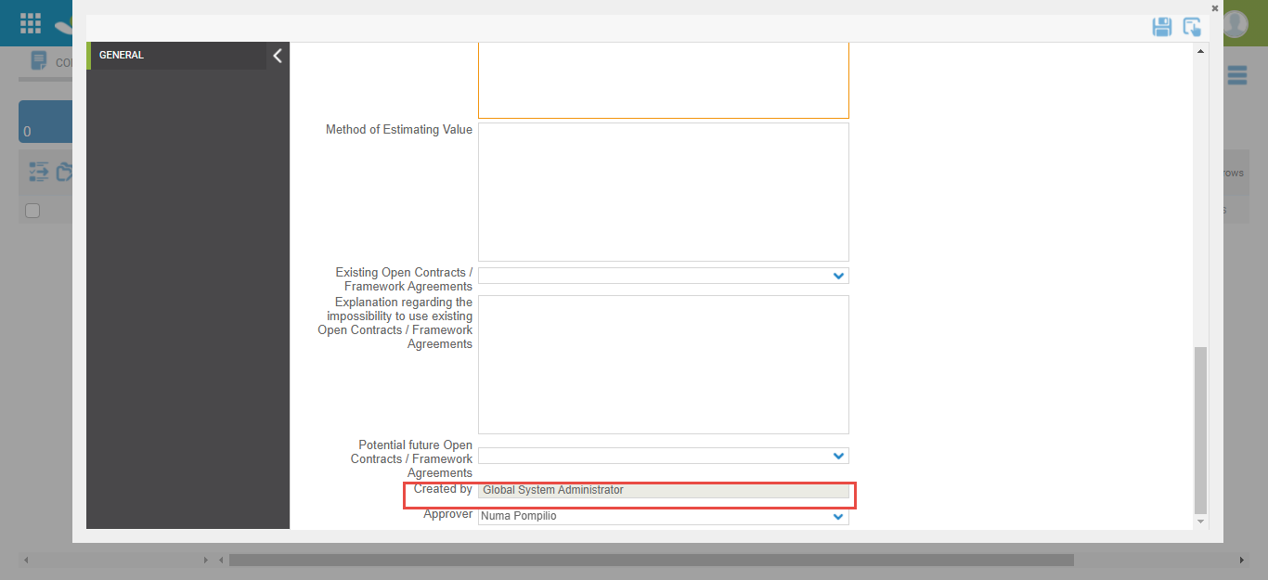

# PRJ Direct Assignment, “Outcome” field logic

Overview:

In this release, we have implemented the **OUTCOME** field in **PRJ DIRECT ASSIGNMENT** form.

Functionality Details:

We have implemented the **OUTCOME** field in **PRJ DIRECT ASSIGNMENT** form and field data shows in wokflow status column on register

* When an object is in the first step then the **workflow status** column will show the workflow status mentioned in the workflow for the first step.
* When an object is in the second step then the **workflow Status** Column will show the workflow status mentioned in the workflow for the second step.
* When an object is in the 3rd step then the **workflow Status** Column will show the workflow status mentioned in the workflow for the 3rd step.
* When an object is released from the 3rd step or finalized, then the **workflow Status** column will show the data as per the value selected in the **Outcome** field. If **“Approved”** is selected in the Outcome field then the **workflow Status** column will show data **“Approved”**
* When an object is released from the 3rd step or finalized, then the **workflow Status** column will show the data as per the value selected in the **Outcome** field. If **“Blank”** is selected in the Outcome field then the **workflow Status** column will show data **“NOT Specified”**
* When an object is released from the 3rd step or finalized, then the **workflow Status** column will show the data as per the value selected in the **Outcome** field. If **“ REJECTED”** is selected in the Outcome field then the **workflow Status** column will show data **“NOT Approved”**

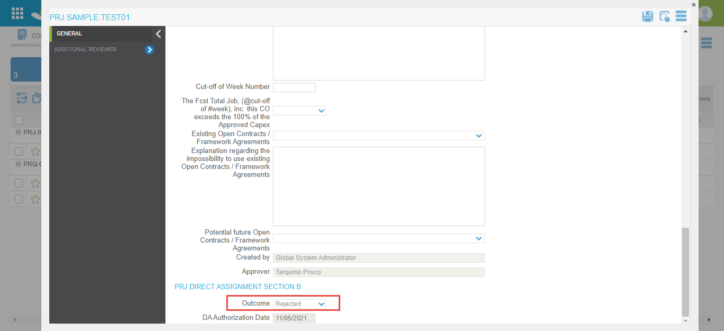

# PRJ Direct Assignment, “DA Authorization Date” field logic

## Overview:

In this release we have implemented **DA AUTHORIZATION DATE** field logic.

## Form Details:

* **DA AUTHORIZATION DATE** field is non editable

## Functionality details:

* Field show the creation date of object , when any object will create then current date will show inn field

